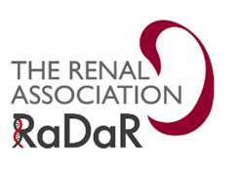
[Unit contact details]

National Registry of Rare Kidney Diseases (RaDaR)
Parent/Guardian Consenting Letter
Dear Parent/Guardian,
Please find enclosed information sheets about the National Registry of Rare Kidney Diseases (RaDaR), a research registry, that your child’s/ward’s renal unit is participating in, which collects information about people with rare kidney diseases.
Please take the time to read the information sheets, which will give you the details about RaDaR and its significance to your child/ward. By consenting to participate in RaDaR, your child’s/ward’s data will be linked to studies, where appropriate, and researchers will be able to contact your child/ward directly about patient information events.
If you would like to consent for your child/ward to take part, please complete the enclosed Consent Form by signing and dating it at the bottom. Please return the form to your renal unit at the address at the top of this letter.
Please note that participation in RaDaR is entirely voluntary and if you choose to not to take part it will not affect your child’s/ward’s treatment or medical care in any way.
If you would like to discuss RaDaR further please contact your kidney doctor or kidney nurse, or contact the RaDaR Operational Officer direct on 0117 4148150 or email nbn-tr.radar@nhs.net.
Thank you for your time.
Yours sincerely,
Encs.

