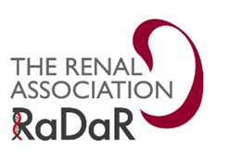
[Unit contact details]

National Registry of Rare Kidney Diseases (RaDaR)
Child to Adult Consenting Letter
Please find enclosed information sheets about the National Registry of Rare Kidney Diseases (RaDaR), which is a research registry that your hospital renal unit is participating in that collects information about people with rare kidney diseases.
Your parents or guardians agreed for you to take part in RaDaR as a child. Now that you are over 16, we would like you to decide on your own behalf if you would like to continue.
Please take the time to read the information sheets, which will give you more details about RaDaR and what it means to you. By consenting to participate in RaDaR, your data will be linked to studies, where appropriate, and researchers will be able to contact you directly about patient information events.
If you would like to consent and continue to take part, please complete the enclosed Consent Form by putting your signing and dating it where indicated. Please return the form to your renal unit at the address at the top of this letter.
Please note that participation in RaDaR is entirely voluntary and if you choose not to take part it will not affect your treatment or medical care in any way.
If you would like to discuss RaDaR further please contact your kidney doctor or kidney nurse, or contact the RaDaR Operational Officer direct on 0117 4148150 or email nbn-tr.radar@nhs.net.
Thank you for your time.
Encs.

