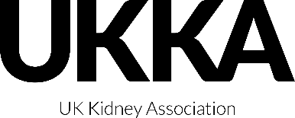
PROXY FORM
THE UK KIDNEY ASSOCIATION (the Company)
2022 Annual General Meeting
Proxy Form
Before completing this form, please read the explanatory notes.

Name:

Address:

Membership Number:

I / We being a member of the Association appoint the Chairman of the meeting or (see note 1)

Name:

as my/our proxy to attend, speak and vote on my/our behalf at the Annual General Meeting of the Association be held via Zoom, on Wednesday 26 October 2022 at 17:00 together with any adjournment of the meeting.

I/We direct my/our proxy to vote on the following resolutions as I/we have indicated by marking the appropriate box with an 'X'. If no indication is given, my/our proxy will vote or abstain from voting at his or her discretion and I/we authorise my/our proxy to vote (or abstain from voting) as he or she thinks fit in relation to any other matter which is properly put before the meeting.

Resolutions | For | Against
1
2
3

Signature:

Date:

