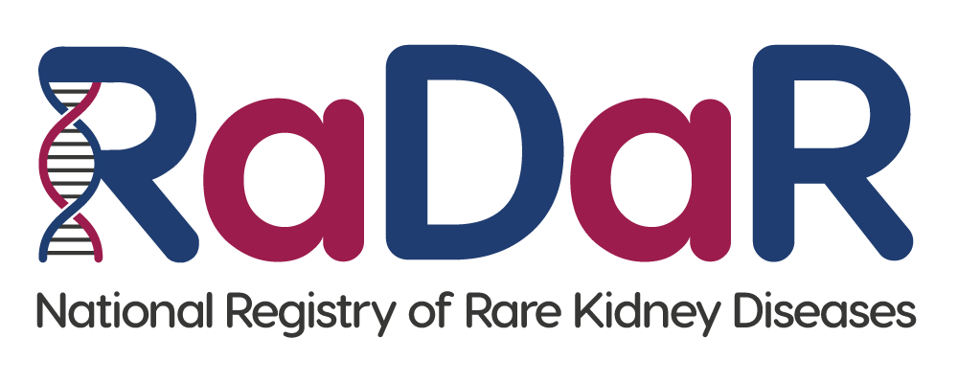

|  |
| --- |
| [Unit contact details] |

**National Registry of Rare Kidney Diseases (RaDaR)**

**Nearest Relative/Guardian or Welfare Attorney Invitation Letter**

Dear Sir/Madam,

[ENTER NAME OF PATIENT] currently lacks the capacity to make an informed decision about whether they can take part in a research study. We are therefore asking you as their nearest relative, welfare attorney or guardian if you will consent on their behalf. This is permissible under the Adults with Incapacity (Scotland) Act 2000.

Please find information enclosed about the National Registry of Rare Kidney Diseases (RaDaR).

RaDaR is a research registry that their hospital kidney unit is participating in. The aim of RaDaR is to collect information we can use to help us understand more about kidney diseases and improve treatments. RaDaR currently holds information on more than 34,000 people and is the largest collection of rare kidney disease data in the world.

Please take the time to read the information. If you decide to give your consent, please complete the enclosed consent form. Please return the form to their kidney unit at the address at the top of this letter.

It is important to know that participation in RaDaR is entirely voluntary and if you decide not to consent, it will not affect their treatment or medical care in any way.

If you have any questions or would like to discuss RaDaR further, please contact their kidney doctor or kidney nurse, or contact the RaDaR Operations Manager using the following email address: radar@ukkidney.org.

Thank you for your time.

Encs.