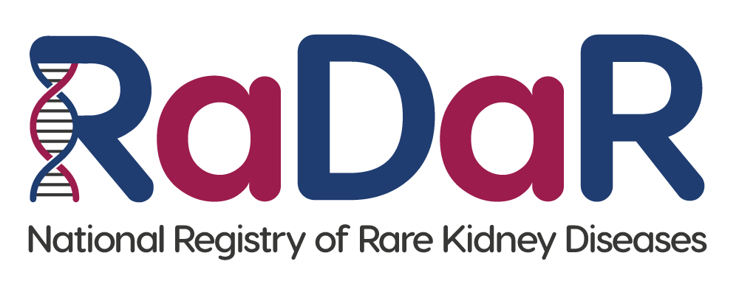

|  |
| --- |
| Patient RaDaR No:  Patient First name, Last name:  Patient Address:  Patient NHS No/CHI No: |

**Parent/Guardian Consent Form (for patients aged 0-15)**

If you agree, please initial box

|  |  |
| --- | --- |
| 1. I confirm that I have read the RaDaR Parent/Guardian Information Sheet dated................(Version........).   I have had the opportunity to consider the information, ask questions and have had these answered satisfactorily. |  |
| 1. I understand that my child’s participation is voluntary and that I am free to withdraw them any time without giving any reason, without their medical care or legal rights being affected. |  |
| 1. I understand that relevant sections of my child’s medical notes and data collected during the study, may be looked at by individuals from RaDaR, from regulatory authorities or from the NHS Trust, where it is relevant to their taking part in this research. I give permission for these individuals to access their records. |  |
| 1. I understand that my child’s past, present and future data will be used for ongoing and future research and may be shared anonymously with other researchers. |  |
| 1. I understand that my child’s data will be linked to other data sources as described in the Information Sheet, and that their personal identifiers (including NHS number and Date of Birth) will be used to search such records. |  |
| 1. I understand that the information held and maintained by RaDaR will be used by the central RaDaR team and Rare Disease Group Lead to contact me. |  |
| 1. My child has provided verbal assent to participate (where age appropriate) and I agree for them to take part in RaDaR. |  |

Name of signatory Date Signature

Signatory email address: __________________________________________________

Relationship to participant (please tick): Parent: Guardian:

Name of Person Date Signature

receiving consent