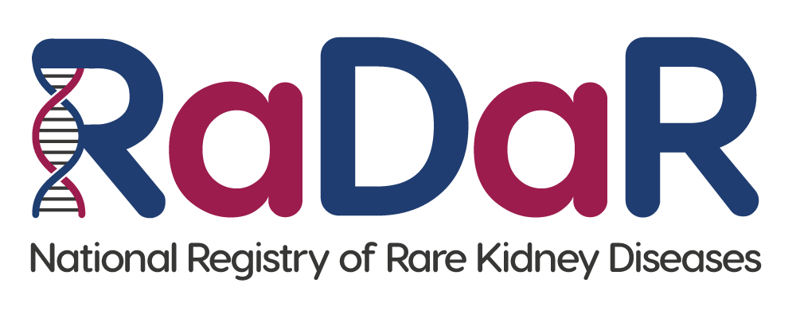

|  |
| --- |
| Patient RaDaR No:  Patient First name, Last name:  Patient Address:  Patient NHS No/CHI No: |

**Consultee Declaration Form**

If you agree, please initial box

|  |  |
| --- | --- |
| 1. I confirm that I have read the RaDaR Consultee Information Sheet dated.................... (Version........). |  |
| 1. As consultee, I have had the opportunity to consider the information, ask questions and have had these answered satisfactorily. |  |
| 1. I understand that this person’s participation is voluntary and that I can request for them to be withdrawn at any time without giving any reason, without their medical care or legal rights being affected. |  |
| 1. I understand that relevant sections of their medical notes and data collected during the study, may be looked at by individuals from RaDaR, from regulatory authorities or from the NHS Trust, where it is relevant to their taking part in this research. I give permission for these individuals to access their records. |  |
| 1. I understand that their past, present and future data will be used for ongoing and future research and may be shared anonymously with other researchers. |  |
| 1. I understand that their data will be linked to other data sources as described in the Patient Information Sheet, and that their personal identifiers (including NHS number and Date of Birth) will be used to search such records. |  |
| 1. I understand that the information held and maintained by RaDaR will be used by the central RaDaR team and Rare Disease Group Lead to contact me. |  |

Name of personal consultee Date Signature

Consultee email address: __________________________________________________

Do you agree to continued use of any data already collected if participation is later withdrawn? Yes No

Name of Person Date Signature

receiving declaration