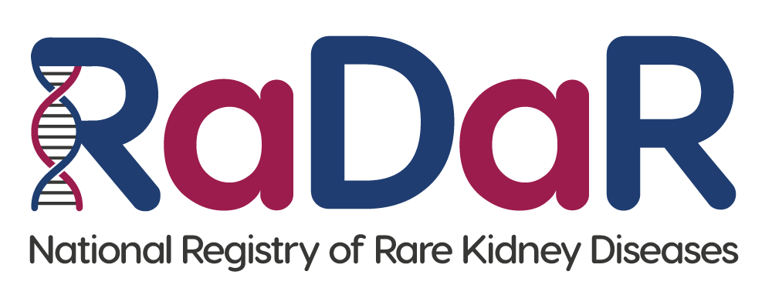

|  |
| --- |
| [Unit contact details] |

**National Registry of Rare Kidney Diseases (RaDaR)**

**Child to Adult Invitation Letter (15 turning 16)**

Dear RaDaR Participant,

We are writing to you as a member of the National Registry of Rare Kidney Diseases (RaDaR). The aim of RaDaR is to collect information to help us understand more about kidney diseases and improve treatments. RaDaR currently holds information on more than 34,000 people and is the largest collection of rare kidney disease data in the world.

As you were younger than 16 when you joined, your parent/guardian would have been asked to sign the consent form. Now that you are turning/have turned 16, you are old enough to decide for yourself if you would like to carry on and to sign your own form.

We have enclosed some information about RaDaR to help you to decide. If you would like to carry on being part of RaDaR, please initial each statement, sign the consent form, and return it to your kidney unit at the address at the top of this letter. If we haven’t heard from you before you reach your 19th birthday, we will stop collecting information about you until we do.

It is important to know that participation in RaDaR is entirely voluntary and if you choose not to carry on taking part it will not affect your treatment or medical care in any way.

If you have any questions or would like to discuss RaDaR further, please contact your kidney doctor or kidney nurse, or contact the RaDaR Operations Manager using the following email address: radar@ukkidney.org.

Thank you for your time.

Encs.