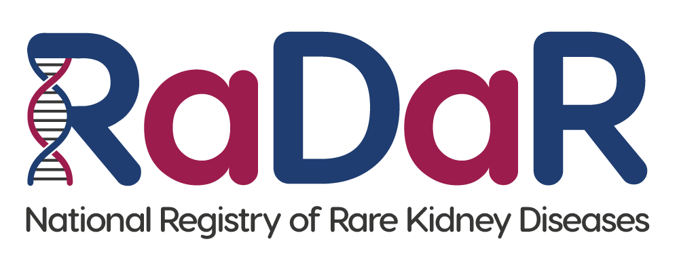

|  |
| --- |
| [Unit contact details] |

**National Registry of Rare Kidney Diseases (RaDaR)**

**Adult Invitation Letter (Age 16+)**

Please find information enclosed about the National Registry of Rare Kidney Diseases (RaDaR).

RaDaR is a research registry that your hospital kidney unit is participating in. The aim of RaDaR is to collect information to help us understand more about kidney diseases and improve treatments. RaDaR currently holds information on more than 34,000 people and is the largest collection of rare kidney disease data in the world.

Please take the time to read the information. If you would like to participate, please complete the enclosed consent form by initialling each statement then signing and dating it at the bottom. Please return the form to your kidney unit at the address at the top of this letter.

It is important to know that participation in RaDaR is entirely voluntary and if you choose not to take part it will not affect your treatment or medical care in any way.

If you have any questions or would like to discuss RaDaR further, please contact your kidney doctor or kidney nurse, or contact the RaDaR Operations Manager using the following email address: radar@ukkidney.org.

Thank you for your time.

Encs.